INTEGERS TO WORDS

WE NEED TO MAP 0-9 11-19 90 -100 FOR VALUES LESS THAN 99

MEANS IF 35 THEN 30 + 5

MEANS IF 11 THEN 10 +1

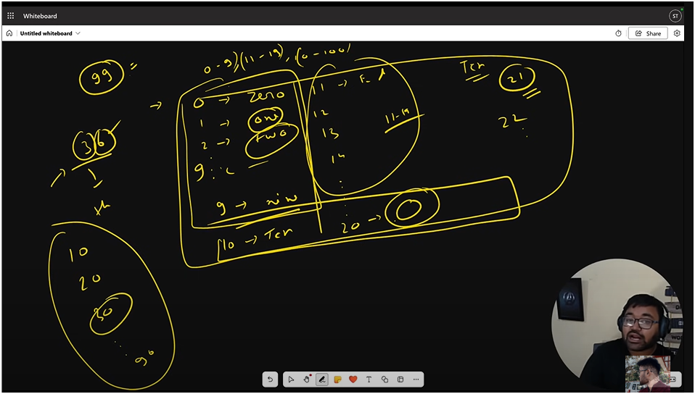

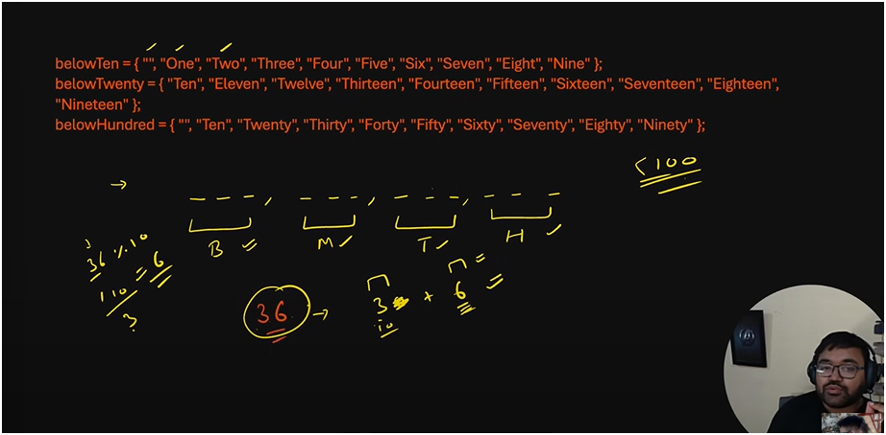

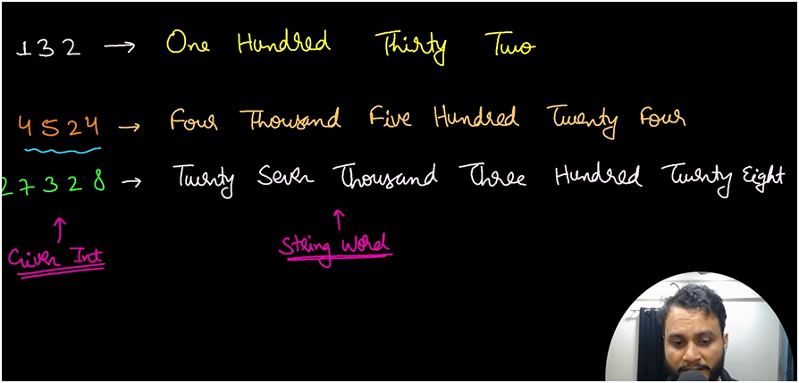

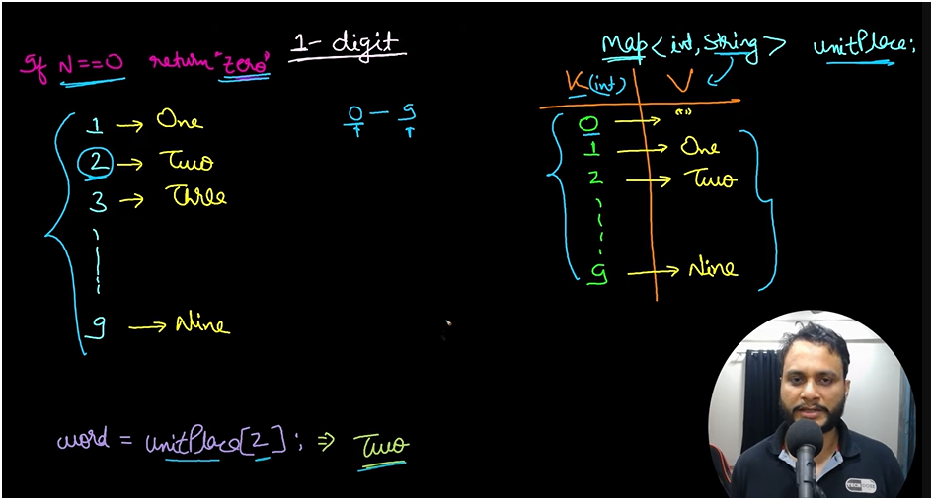

MAKE A MAPPING WHERE WE HAVE IDS RANGING BETWEEN 0-9 AND JUST WE NEED TO PASS INPUT OF NUMBER TO FUNCTION unitplace THEN FUNCTION WILL SEE IDS IF MATCHED THEN IT WILL RETURN VALUES

EG:- INPUT:-2

IN MAP ID:2 REFERS TO TWO

THEN IT WILL RETURN TWO AS STRING

IF ON UNIT PLACE THE ZERO IS THEN RETURN NOITHING

2 1 0

HUNDRED TENS UNIT PLACES

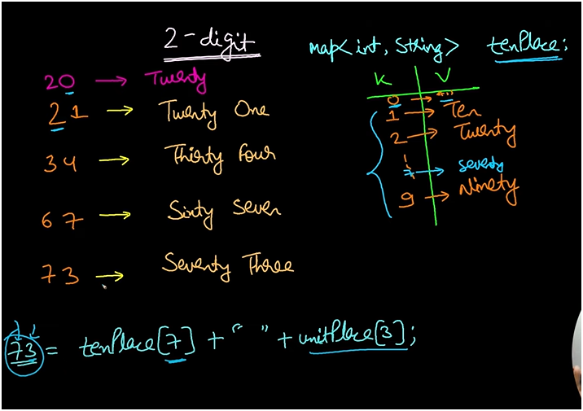

IF THE DIGIT IS ON TENS PLACE MEANS THEN PASS THE TENS DIGIT TO TENSPLACE FUNCTION THEN IN TENSPLACE FUNCTION IT WILL SEARCH FOR IDS AND THEN RETURN VALUE

EG

IF ON TENS PLACE IT IS 7 THEN IT WILL SEARCH FOR ID:7 THEN IT WILL RETURN VALUE:SEVENTY

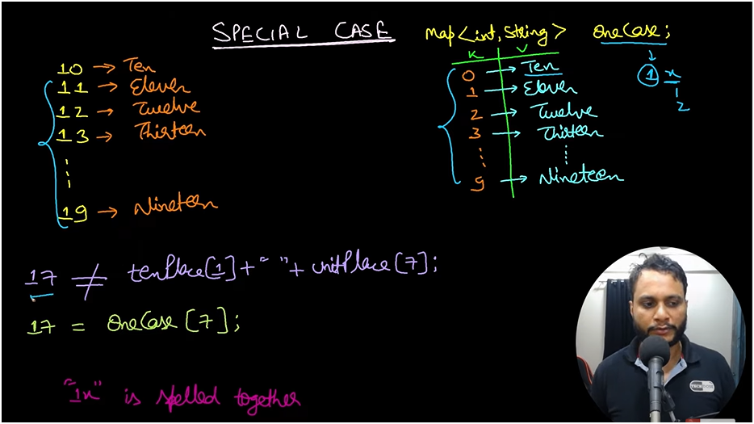

FOR SOME SPECAIL CASE IF ON TENS PLACE IT IS 1 THEN THERE WILL BE DIFFERENT MAPPING IDS AND VALUES MEANS IT WILL BE BETWEEN ELEVEN TO NINENTEEN

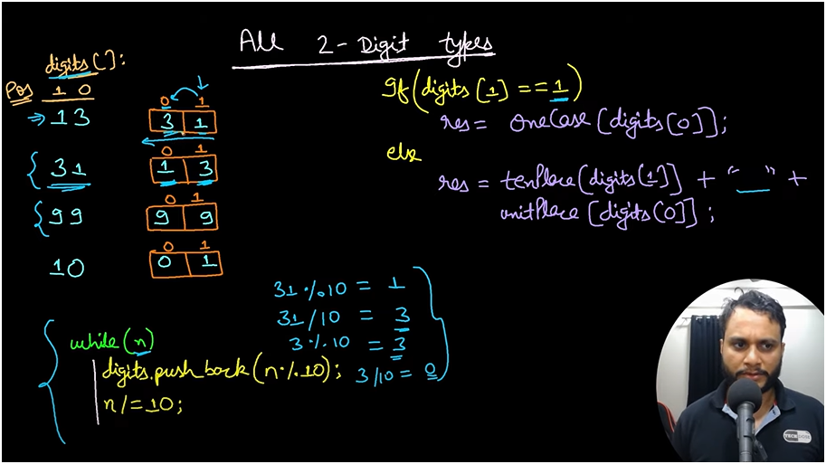

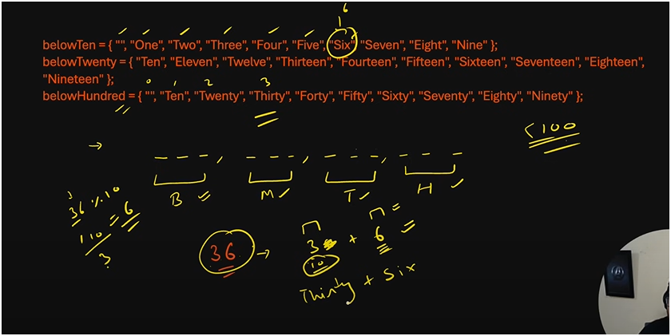

BELOW TEN UNIT PLACE

BELOW HUNDRED TENS PLACE

BELOW TWENTY SPECIAL CASE

* **FOR UNITS(NOTHING)**
* **FOR ONE DIGIT** 
  + **DIRECT SEARCH UNDER BELOW TEN**
* **FOR TWENTYS**

**FOR TWO DIGITS BELOW TWENTY**

* + **IF NUMBER IS 18 THAT IS EIGHTEEN**
    - **WE CANT SEPARATE IT THEN JUST SEE IN BELOW TWENTY**
* **FOR 100(DIVIDE BY 10)**
  + **NUMBER IS 74 THAT IS SEVENTY AND FOUR**
    - **THUS WE SEE SEVENTY IN BELOW HUNDRED** 
      * **BUT HOW SEVENTY IS SEARCHED IN ARRAY FOR THAT WE NEED INDEX SO WE DIVIDE 74 BY 10 TO GET INDEX NUMBR 7 AND THEN SEARCH**
    - **AND WE SEE FOUR IN BELOW TEN**
  + **AND NUMBER IS 70 THAT IS SEVENTY**
    - **FOR THAT CASE SEARCH SEVENTY IN BELOW HUNDRED**
    - **AD FOR ZERO IGNORE**
* **FOR THOUSANDS(DIVIDE AND MODULUS BY 100)**
  + **IF DIGIT IS 944 NINE HUNDRED AND FORTY FOUR**
  + **THEN DO DIVIDE AND MODULUS BY 100**
  + **DIVIDE BY 100 GIVES U 9**
    - **SEARCH BELOW TEN**
  + **APPEND** 
    - **HUNDRED IN IT**
  + **AND MODULUS BY 100 GIVE U 44**
    - **IF MODULUS IS NOT ZERO THEN** 
      * **JUST APPEND BLANK AND**
      * **JUST DO RECURSIVE CALL FOR TWO DIGIT**
* **FOR LAKHS(DIVIDE AND MODULUS BY 1000)**

**FOR FOUR DIGIT TO SIX DIGIT (THEN DIVIDE AND MODULUS BY 1000)**

* + **IF DIGIT IS 9444 NINE THOUSAND FOUR HUNDRED AND FORTY FOUR**
  + **OR DIGIT IS 999 000 NINE HUNDRED AND NINTY NINE THOUSAND**
  + **THEN DO DIVIDE AND MODULUS BY 1000**
  + **DIVIDE BY 1000** 
    - **AND GO TO RECURSIVE CALL**
  + **APPEND** 
    - **THOUSAND IN IT**
  + **AND MODULUS BY 1000 GIVE U 444**
    - **IF MODULUS IS NOT ZERO THEN** 
      * **JUST APPEND BLANK AND**
      * **JUST DO RECURSIVE CALL FOR THREE DIGIT**
* **FOR MILLIONS(DIVIDE AND MODULUS BY 10^6)**
* **FOR BIILIONS(DIVIDE AND MODULUS BY 10^9)**

**QUICK TRICK**

* IF NUM IS ZERO THEN PRINT ZERO
  + DIRECT ZERO
* IF NUM IS BELOW 10 MEANS BETWEEN 0 TO 9 THEN SEE UNDER BELOWTEN ARRAY
  + DIRECT SEARCH
* IF NUM IS BELOW TWENTY BETWEEN 10 TO 19 THEN SEE UNDER BELOWTWENTY ARRAY
  + DIRECT SEARCH
* IF NUM IS BELOW HUNDRED THEN SEE UNDER BELOW TWENTY AND BELOW TEN ARRRAY
  + DIVIDE AND MODULUS BY 10
* IF NUM IS BELOW THOUSAND THEN SEE UNDER BELOW TEN AND DO RECURIVE CALLS FOR LAST TWO DIGITS
  + DIVIDE AND MODULUS BY 100
* IF NUMBER IS BELOW LAKH(10^6)THEN DO RECURSIVE CALLS AND THOUSAND DO RECURIVE CALLS FOR LAST THREE DIGITS
  + DIVIDE AND MODULUS BY 1000
* IF NUMBER IS BELOW MILLION(10^9)THEN DO RECURSIVE CALLS AND MILLIONS DO RECURIVE CALLS FOR LAST 6 DIGITS
  + DIVIDE AND MODULUS BY 1 000 000
* ELSE THEN DO RECURSIVE CALLS AND BILLIONS DO RECURIVE CALLS FOR LAST 9 DIGITS
  + DIVIDE AND MODULUS BY 1 000 000 000